26考研英语零基础语法
杨凡达老师
Lesson 2

并列连词FANBOYS
句子主干
二、定语、状语和同位语
定语：修饰名词或代词（...的）
状语：修饰动词、形容词、副词或句子（...地）
同位语：修饰名词或代词，补充说明信息
[状语] On September 11, 2001,
[主干] [定语]two hijacked被劫持的 airplanes | [谓语]crashed | [状语]into the “twin towers”双子塔
—[同位语] the headquarter of WTO世界贸易组织的总部.
<提炼核心> airplanes crashed

1. 定语
前缀和后缀
前置定语和后置定语
定语的左三（限定词、名词、形容词）和右四（形容词短语、副词短语、介词短语、分词短语）规律

名词短语：前置定语 + 中心词 + 后置定语
[限定词]a pair of一对 |[形容词]vivid栩栩如生的 |[名词]stone石头 ｜｜lions狮子 ｜｜[介词短语]in front of a temple在一座庙宇前的 | [分词短语]standing on a mountain立在一座山上的 |[形容词短语]full of ancient buildings布满古建筑的

【前置定语的顺序：限定词（冠词a, an, the/数词/代词/名词所有格）-->形容词-->名词】
最佳｜女子｜网球｜运动员
[限定词]the [形容词]best [名词]female tennis player/athlete
三台旧空调air conditioner
[限定词]three | [形容词]old | [名词]air | conditioners
中国的｜低｜生育｜率
[限定词：名词所有格]China’s |[形容词]low | [名词]birth | rate
这种this |令人担忧的disturbing |人才|流失loss brain drain
This代词[限定词] | disturbing[形容词] | brain drain

【多个形容词顺序：评价、尺寸、新旧、形状、颜色、出处、材料、目的】
口诀：美小旧圆黄，法国木书房
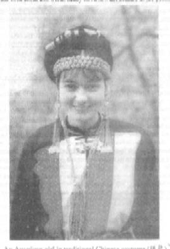
2002年英语作文真题
女子：美国American、年轻young、漂亮beautiful、身材好slender/sexy
A beautiful young slender American girl

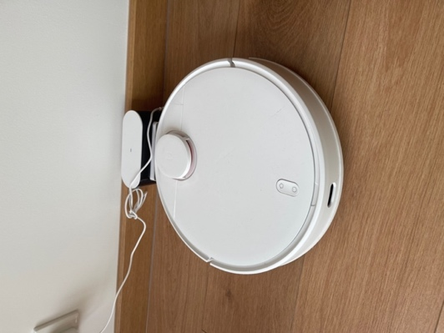
扫地机器人robot vacuum cleaner：白的white、圆的round、中国制造的made-in-China、小巧的small
a small round white made-in-China robot vacuum cleaner

【后置定语两种关系】
关系1：名词 <-- 后置定语1 + 后置定语2
a film | [后置定语1:介词短语]about space travel | [后置定语2:分词短语]directed by Christopher Nolan诺兰

关系2：名词 <-- 后置定语1 <-- 后置定语2
a film | [后置定语1] about space travel | [后置定语2：修饰travel] to Mars
一部关于火星太空旅行的电影

<歧义！a hotel | [后置定语1] with有/配备 an in-door swimming pool室内泳池 | [后置定语2] suitable for introverts适合内向的人的>
改造一：a hotel （that features具有...特征 an in-door swimming pool suitable for introverts）
改造二：（a hotel with an in-door swimming pool配有室内泳池的酒店）, suitable for introverts适合i人

2. 状语
【特殊状语：名词短语】
我家距离市中心有十公里ten kilometers。
My home is [状语]ten kilometers away from the city center.
上海中心有632米高。
Shanghai Center is [状语]632 meters high.
Shanghai Center is very high.

昨天我去打篮球了。
我昨天去打篮球了。
Yesterday I played basketball.
I played basketball yesterday.

【主干（主谓宾/主系表）后的状语位置：方式 --> 地点 --> 时间】
他们｜【时间】昨晚｜【地点】在in实验室lab｜【方式】认真地｜写｜报告report。
They wrote the report | carefully | in the lab | yesterday evening.
报告：他们正在写的那个报告
实验室：他们所工作/学习的那个实验室
描述事物：泛指（泛泛而谈，不指定）和特指（指定某一个或某一些）

【时间/地点状语按照“从小到大”顺序来书写】
<失物招领> 我｜在省图书馆阅览室长椅上｜捡到了｜一个钱包。
I picked up a wallet on（接触） a bench in（在...内） the reading room of（所属/组织部分） the provincial library.
在省图书馆（唯一）the provincial library|阅览室（唯一）the reading room|（某张）长椅上a bench

3. 同位语：补充说明代词或名词的信息
[主语]Yang Fanda, [同位语]an English teacher in his forties, [谓语]loves [宾语]playing games, [同位语]especially board games桌游（三国杀、狼人杀、剧本杀）.

Yang Fanda is an English teacher in his forties.主系表

Of = ...的
【of结构同位语】
the district of Honggutan 红谷滩的行政区❌
红谷滩这个行政区
the month of January 一月的月❌
一月这个月份
the habit of smoking 吸烟的习惯☑️
the habit = smoking 吸烟这种习惯
the game of hide-and-seek躲猫猫/捉迷藏
躲猫猫这个游戏

【同位语在写作中的运用——提供细节】
[主语]越来越多的人｜[谓语]开始｜[宾语]养宠物raise/keep pets。
Start doing something
More and more people start raising pets.
尤其什么人？年轻、独居、有爱心
什么样的宠物？猫、狗、乌龟tortoise、兔子、鱼、蜥蜴
Turtle海龟
More and more people, especially those who live alone, start raising pets, such as cats, dogs, rabbits and lizards.

在未来，老人｜将由｜机器人｜照顾care for / take care of / look after。
In the future, old people will be cared for by robots.
什么样的老人？独居的、腿脚不便的、残疾的
什么样的机器人？人形机器人
In the future, old people, especially those who live alone or are disabled, will be cared for by robots, such as humanoid robots.

微博：杨凡达

